Raiyan Janik Monir

Database Testing

1. Query 1: SELECT \* FROM Student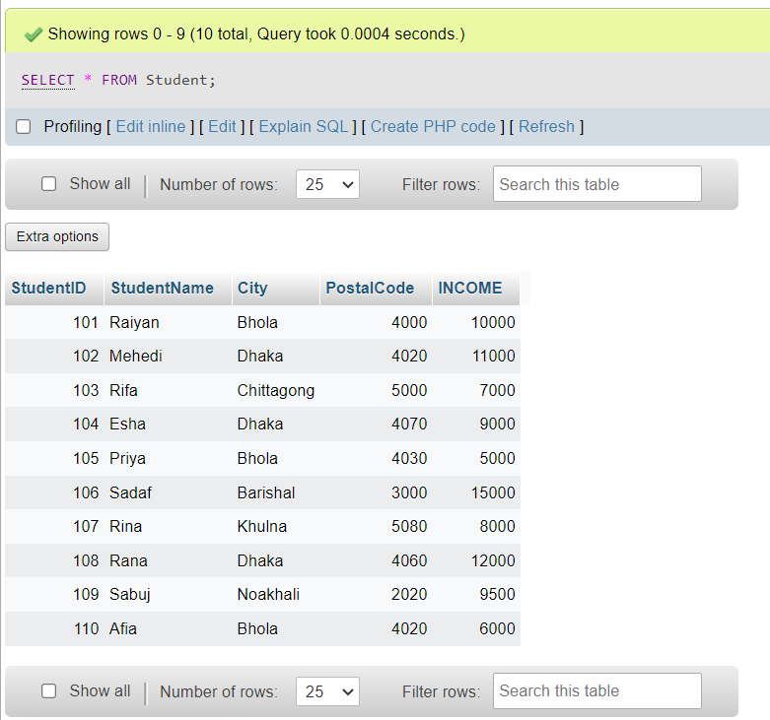
2. Query 2: SELECT DISTINCT City FROM Student;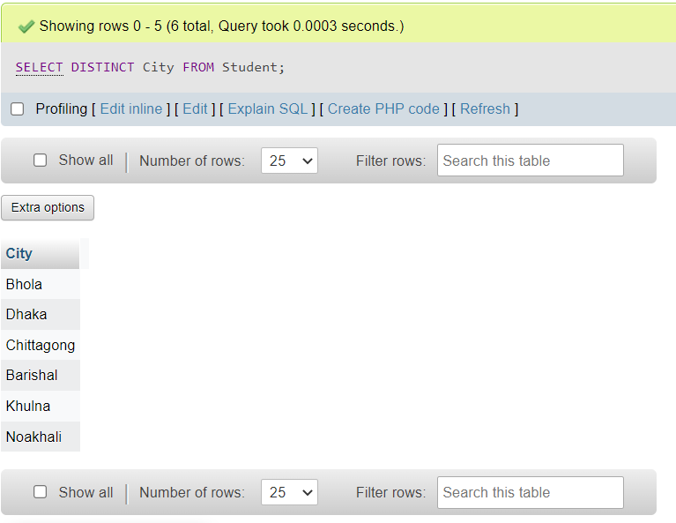
3. Query 3: SELECT COUNT(DISTINCT City) FROM Student;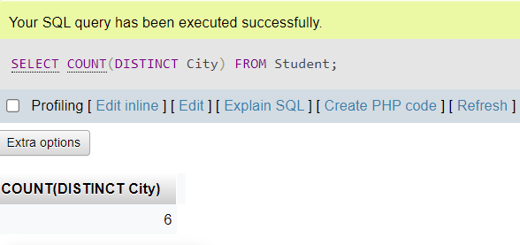
4. Query 4: SELECT \* FROM Student WHERE City='Bhola';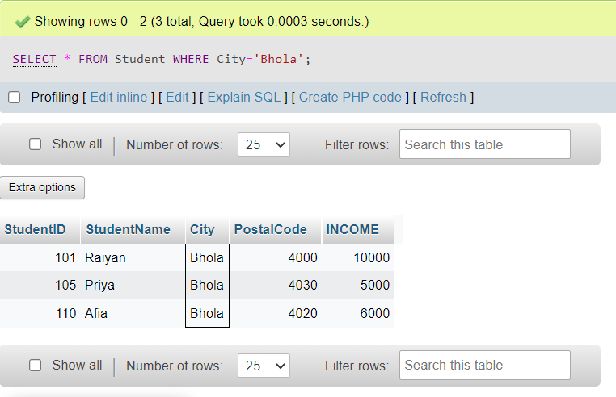
5. Query 5: SELECT \* FROM Student WHERE StudentID=101;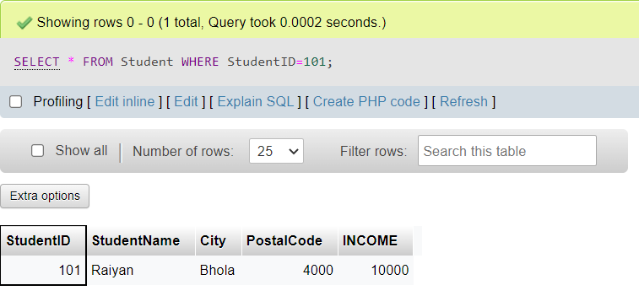
6. Query 8: SELECT \* FROM Student WHERE NOT City='Comilla';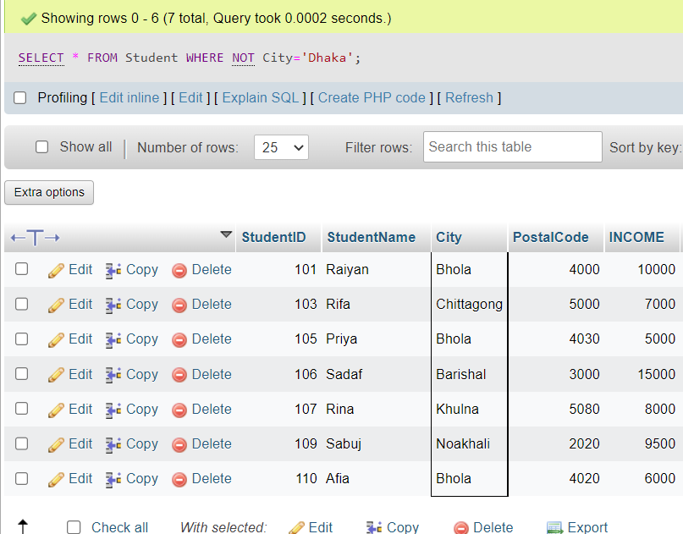
7. Query 9: SELECT \* FROM Student ORDER BY City;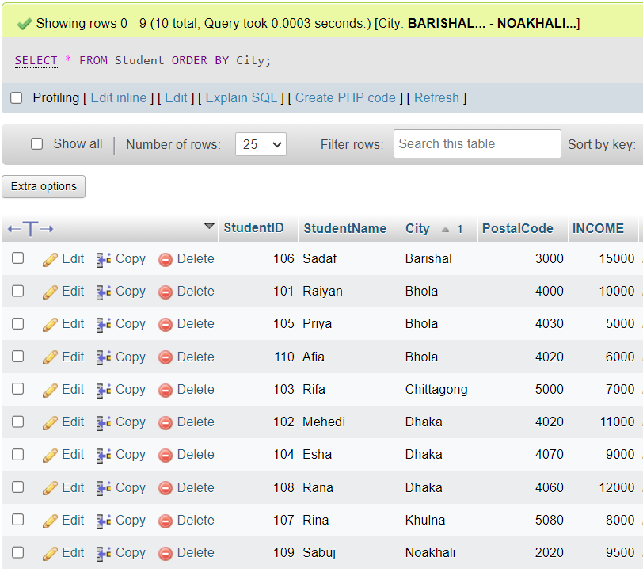
8. Query 11: UPDATE Student SET StudentName = 'Hasan', City= 'Cumilla' WHERE CustomerID = 102;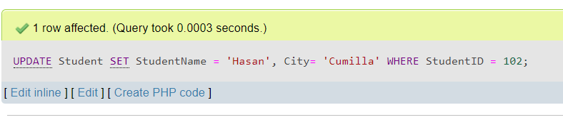
9. Query 12: DELETE FROM Student WHERE StudentName='Rina';

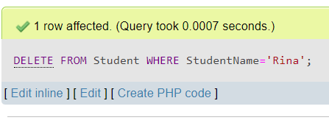

1. Query 13 : SELECT \* FROM Student WHERE Income BETWEEN 10000 AND 200000;

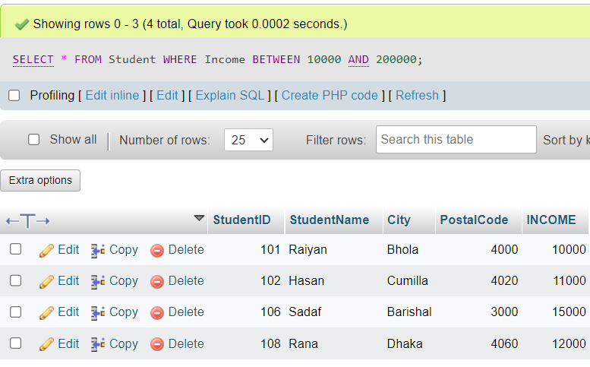

1. Query 14: SELECT MIN(INCOME) FROM Student;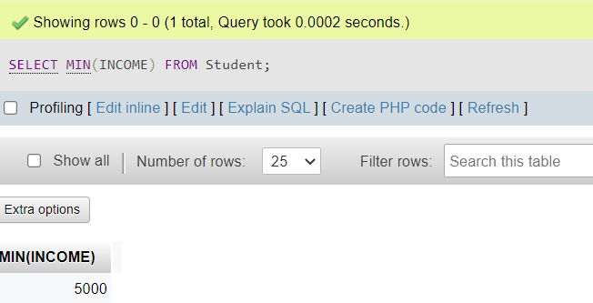
2. Query 15: SELECT MAX(INCOME) FROM Student;